Git
Ruff

Radon
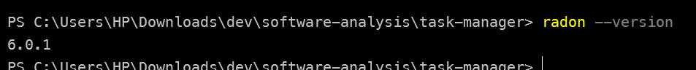
Python
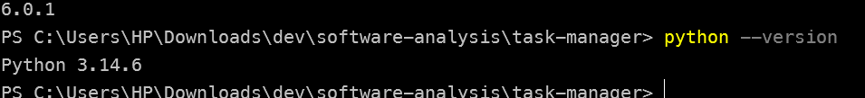
Ai assistant

RuFF check (Static)
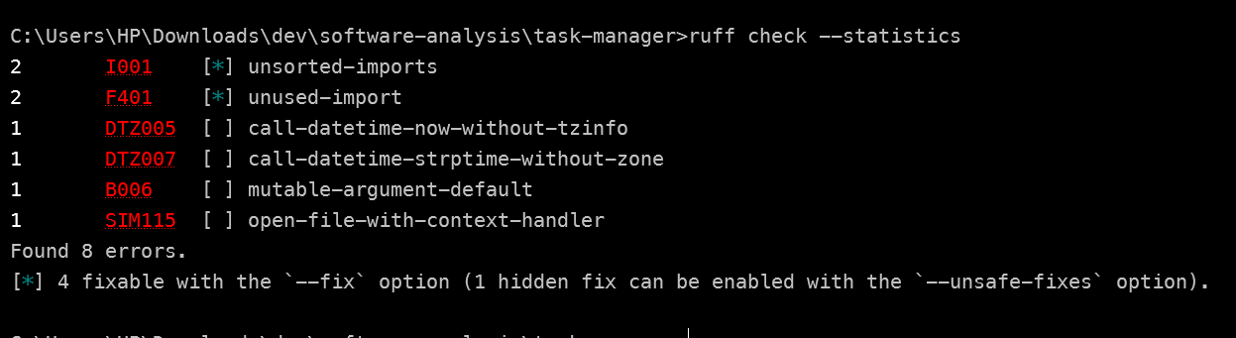

Pytest run (Dynamic)
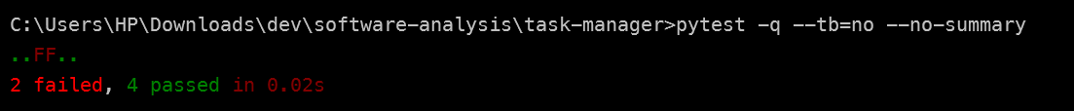

Defects
ID | File | Line | Description | Severity
1 | app/tasks.py | 23 | tags=[] mutable default argument — every task created without explicit tags shares the same list object; mutating one task's tags corrupts others | High
2 | app/tasks.py | 26 | id = len(tasks) + 1 — after a task is removed, the next generated ID collides with still-existing IDs, producing duplicate task IDs | Medium
3 | app/tasks.py | 48 | range(1, len(tasks)) — off-by-one loop that skips index 0 (the first task is never considered) | High
4 | app/tasks.py | 59 | total / len(tasks) — no empty-list guard; dividing by zero raises ZeroDivisionError | High
5 | app/tasks.py | 62–66 | find_task_by_title — no explicit return when no match is found; falls off the end and silently returns None | Medium
6 | app/tasks.py | 69–74 | remove_task — returns None whether or not the task existed; callers cannot tell if removal succeeded | Low
7 | app/tasks.py | 79 | if is_premium == True — non-idiomatic comparison to True (PEP 8 E712) | Low
8 | app/tasks.py | 11 | f = open(...) without a with block — file handle is never closed; corrupt or null JSON flows through with no validation that the result is a list | Medium
9 | app/storage.py | 11 | "Task #" + task["id"] + ": " — string concatenation with an integer → TypeError at runtime | High
10 | app/storage.py | 4 | Hardcoded API_KEY secret committed in source (TODO even admits it should be an env var) | High
11 | app/storage.py | 26 | build_query — SQL built via naive string concatenation → SQL injection vulnerability | High
12 | app/storage.py | 18–21 | days_until_due — datetime.now() includes time-of-day; truncation to .days can be off by one depending on the current time | Low

2. Triage Table

ID | Tool message (file:line) | Verdict | Code-anchored justification
F1 | ruff B006: Do not use mutable data structures for argument defaults - default is [] (app/tasks.py:23) | REAL DEFECT | tags=[] is evaluated once at def-time, so every task created without tags shares ONE list object. Mutating one task's tags (app/tasks.py:29 stores the reference) corrupts every other untagged task.
F2 | ruff SIM115: Use a context manager for opening files - f = open(TASKS_FILE, 'r') (app/tasks.py:11) | REAL DEFECT | The handle is never closed. If json.load raises (corrupt file), the 'with' version still closes; this version leaks the handle on every failure path and even on success.
F3 | bandit S608: Possible SQL injection vector through string-based query construction (app/storage.py:26) | REAL DEFECT | title_filter is concatenated straight into SQL. Any quote + OR pattern changes the query's meaning - the user's string is parsed as SQL, not compared as data.
F4 | ruff E712: Comparison to True - change to 'if is_premium:' (app/tasks.py:79) | NOISE | Both callers pass real booleans (True / False from the tests). == True then behaves identically to a truthy check for these inputs, so reported behaviour is fine. It is a style suggestion with zero runtime impact - flagged on the syntax tree, not on behaviour.
F5 | pylint W0611: Unused import save_tasks (app/cli.py:2) | NOISE | An unused import has no runtime effect on the executed path (Python binds the name and never uses it). The module has no import-time side effects here, so removing it changes nothing observable. Dead reference yes; defect affecting correctness no.

3.1 Reading an analyzer message

Part | Example
Rule code | S608
Location | app/tasks.py:23
Message text | Do not use mutable data structures for argument defaults
 | perhaps use 'list' as default or None

4.1 Which Lab 1 defects a static analyzer would catch

Lab defect | Static analyzer catches? | Why (principle)
1 mutable default tags (tasks.py:23) | YES | Pure syntax: B006 inspects the signature's default node. No execution needed.
8 unclosed open (tasks.py:11) | YES | SIM115 sees an open() call not wrapped in a context manager - structural rule.
10 hardcoded API key (storage.py:4) | YES | bandit B105 checks for secret-like literals and names - pattern match.
11 SQL injection (storage.py:26) | YES (typical case) | S608 taint looks for user-controlled names concatenated into an SQL string. Honest caveat: heuristic - a cleverly hidden query would slip through, which is why defenders still use parameterized queries.
7 == True (tasks.py:79) | YES (as a style warning) | E712 is an AST pattern; it fires, but as Section 2 shows, this one is NOISE behaviourally.
5 implicit None return (tasks.py:62-66) | PARTIAL | pylint inconsistent-return-statements can warn when one path returns a value and another falls off the end - a control-flow check. A simpler linter would miss it.
3 off-by-one range(1, len) (tasks.py:48) | NO | range(1, len(tasks)) is valid syntax and no rule knows your COUNTING intent. Only reading the docstring ('all tasks not done') against the first-index choice exposes it. Needs human reasoning or a dynamic test with the first element.
4 division by zero on empty list (tasks.py:59) | NO | len(tasks) is 0 only for a RUNTIME value. Static scan has no value information; the crash only exists when the function is executed with an empty list (which is exactly why the test test_average_priority_of_empty_list fails).
9 string + integer (storage.py:11) | NO (plain linters) / YES (typed checkers) | task['id'] has no declared type, so ruff/flake8 cannot know it is an int. mypy or pyright COULD with annotations/inference; otherwise the TypeError appears only when format_task_report actually runs on a real task - dynamic.
2 re-used task IDs (tasks.py:26) | NO | ID duplicates are a function of the runtime lifecycle (add -> remove -> add). A static tool would need to simulate all that state, which it does not.
12 due-date truncation (storage.py:18-21) | NO | The off-by-one depends on the current wall-clock time at execution - a runtime value by definition. Dynamic testing (or reading datetime semantics) is the only way to see it.
6 remove_task returns nothing (tasks.py:69-74) | PARTIAL / NO | A linter cannot judge that callers EXPECT a status; this is an API-design judgement found by comparing remove_task (no return) with complete_task (returns True/False) at review time.

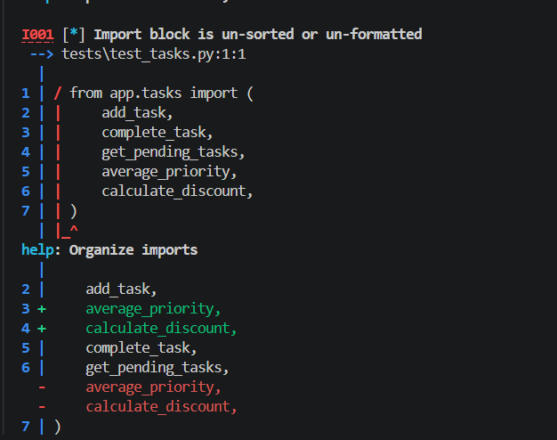
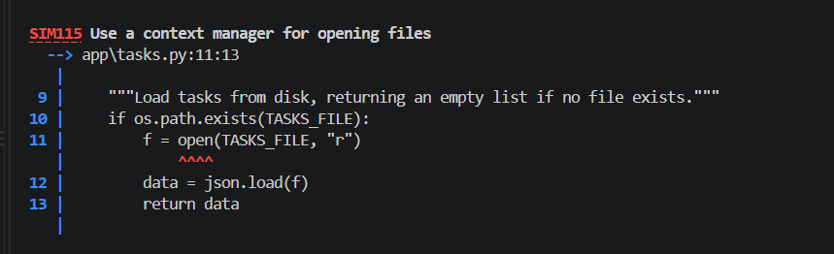
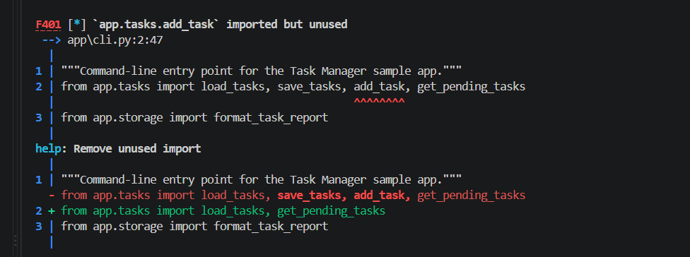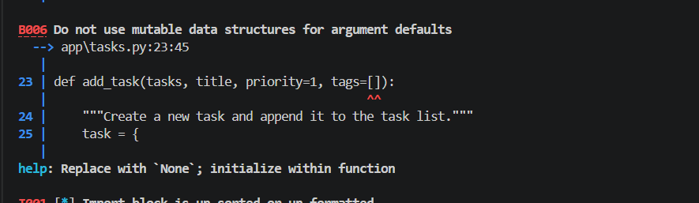

Cyclomatic Complexity
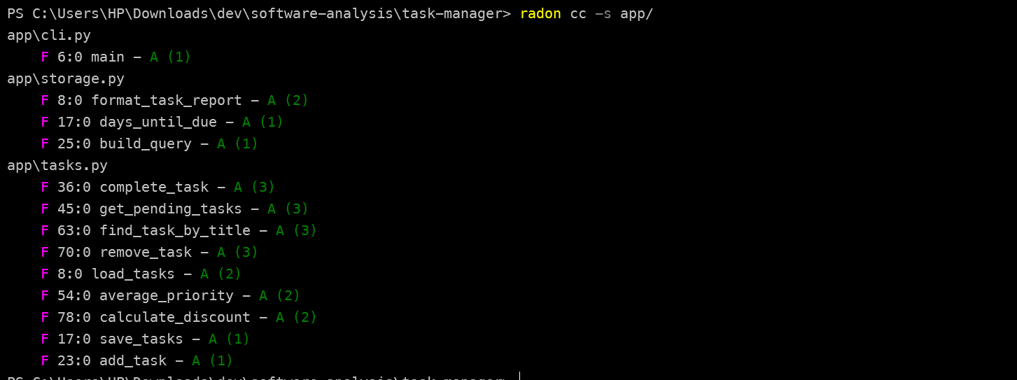
All functions have A complexity (best rating). The codebase has low cyclomatic complexity across the board.

